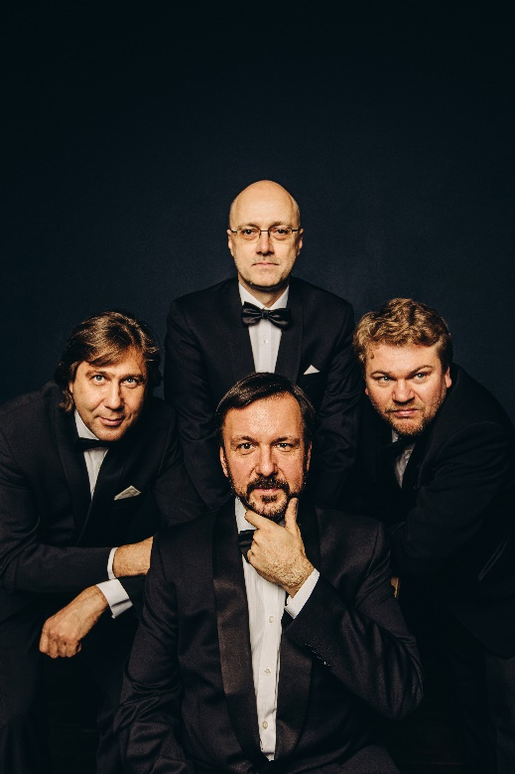

“their almost preternatural ability to synchronise as though they were one single instrument.”
The Independent

Nikolai Sachenko - violin
Sergei Lomovsky - violin
Igor Naidin - viola
Vladimir Balshin – cello

In 2025, the Borodin Quartet celebrated its 80th anniversary: the quartet has, for more than seventy years, been acclaimed for its insight and authority in the chamber music repertoire. Revered for its searching performances of Beethoven and Shostakovich, the Quartet is equally at home in music ranging from Mozart to Stravinsky.

Described by the Daily Telegraph Australia as “the Russian grand masters”, the Borodin Quartet’s particular affinity with Russian repertoire is based on constant promotion, performances and recording of the pillars of Russian string quartet music - Borodin, Tchaikovsky, and Shostakovich, as well as Stravinsky, Prokofiev and Schnittke.

The Quartet is universally recognised for its genuine interpretation of Russian music, generating critical acclaim all over the world; the Frankfurter Allgemeine Zeitung writes about them “here we have not four individual players, but a single sixteen-stringed instrument of great virtuosity”.

The Quartet's connection with Shostakovich's chamber music is intensely personal, since it was stimulated by a close relationship with the composer, who personally supervised its study of each of his quartets. Widely regarded as definitive interpretations, the Quartet’s cycles of the complete Shostakovich's quartets have been performed all over the world, including Vienna, Zurich, Frankfurt, Madrid, Lisbon, Seville, London, Paris, and New York. The idea of performing a complete cycle of Shostakovich's quartets originated with the Borodin Quartet. In recent seasons, the ensemble has returned to a broader repertoire, including works by Schubert, Prokofiev, Borodin, and Tchaikovsky, while continuing to be welcomed and acclaimed at major venues throughout the world.

The Borodin Quartet was formed in 1945 by four students from the Moscow Conservatory and remains one of the very few existing established chamber ensembles with uninterrupted longevity. Over those eight decades the Borodin Quartet has retained its commitment to tonal beauty, technical excellence, and penetrating musicianship. The ensemble’s cohesion and vision have survived successive changes in personnel, thanks not least to the common legacy shared by its members from their training at the Moscow Conservatory. The current members of

the Quartet are Nikolai Sachenko, Sergei Lomovsky, Igor Naidin and Vladimir Balshin.

In addition to performing quartets, the Borodin Quartet regularly joins forces with other distinguished musicians to further explore the chamber music repertoire. Their partners have included Sviatoslav Richter, Yuri Bashmet, Michael Collins, Alexei Volodin, Barry Douglas, Mario Brunello, Elisabeth Leonskaja, Christoph Eschenbach, Boris Berezovsky, and Nikolai Lugansky.

The Quartet also regularly receives invitations to give masterclasses, and to serve as jury members at major international competitions.

Recent appearances include performances in Europe at venues including BOZAR in Brussels, Berlin Konzerthaus, Liszt Academy in Budapest, Muziekgebouw Eindhoven, Tivoli Vredenburg Utrecht, Philharmonie de Paris and Amsterdam Concertgebouw. The Quartet also recently embarked on a tour of China, a country they will revisit on a major tour in December 2025.

The Quartet’s first release on the Onyx label, featuring Borodin, Schubert, Webern and Rachmaninov, was nominated for a Grammy in 2005 in the “Best Chamber Performance” category. The Borodin Quartet has produced a rich heritage of recordings over several decades, for labels including EMI, RCA and Teldec, including the Complete Beethoven quartets for CHANDOS. The Quartet’s recording of the complete Shostakovich String Quartet Cycle for Decca was released in September 2018, following the first release in the cycle, a dedicated 70th anniversary CD (of string quartets Nos.1, 8, and 14), released in March 2015.

Valid for use until 1 September 2026
For updated versions please contact
info@rayfieldallied.com

